PRESS RELEASE
Warsaw, May 22, 2025

The spiral of silence in Poland – we do not want to publicly express opinions that we perceive as inconsistent with the majority view
Over two-thirds of Polish women and men oppose sending Polish troops to Ukraine, according to a nationwide survey conducted by the Laboratory of Media Studies at the University of Warsaw. Sixty-five percent of respondents do not support such involvement, and at the same time, the majority believe that society shares their position—both now and in the future. The study, aimed at examining whether the so-called spiral of silence operates in Poland, also reveals that only slightly more than half of citizens are willing to discuss this topic publicly, for example, on a train, even though nearly half declare a willingness to speak out in discussions on controversial issues. Meanwhile, as many as 78% of participants declared their intention to take part in the upcoming presidential elections.
During the week of May 12–16, 2025, the Laboratory of Media Studies at the University of Warsaw conducted a survey using the CATI method (Computer Assisted Telephone Interview). Over five consecutive days, interviewers carried out interviews with a total of 1,100 respondents.
The survey aimed to examine whether the phenomenon known as the spiral of silence occurs in Polish society. The spiral of silence concept, developed by German researcher Elisabeth Noelle-Neumann in the 1970s, assumes that people, fearing social isolation, refrain from expressing opinions they perceive as differing from the majority view. The team at the Laboratory of Media Studies at the University of Warsaw prepared the survey questions following the original framework tested by the concept’s creator, while the subject of the study was the issue of sending Polish troops to Ukraine. At the end, respondents were asked whether they intended to participate in the upcoming presidential election on Sunday (first round), and demographic questions (gender, age, education, and residential locality code) were included to enable weighting of the data. This weighting process ensured that the statistical proportions reflected the adult Polish population, as represented in the databases of the Central Statistical Office, which are based on the full population data from the 2021 National Census of Population and Housing.

The survey included the following questions:

- Do you think the Polish military should take part in stabilizing the situation on the Ukrainian-Russian border? Please select one answer—from strongly agree to strongly disagree.
- In your opinion, do most Poles agree with your view on this matter?
- In your opinion, will most Poles agree with your view on this matter in the future?
- Would you be willing to express your opinion on the involvement of the Polish military in stabilizing the Ukrainian-Russian border during a conversation with other passengers on a train?
- Please rate on a scale how willing you are to discuss controversial topics in public.
- Will you participate in the upcoming election this Sunday?

Results – the distribution of answers to each question – are as follows:
Question 1: Do you think the Polish military should take part in stabilizing the situation on the Ukrainian-Russian border? Please select one answer—from strongly agree to strongly disagree.
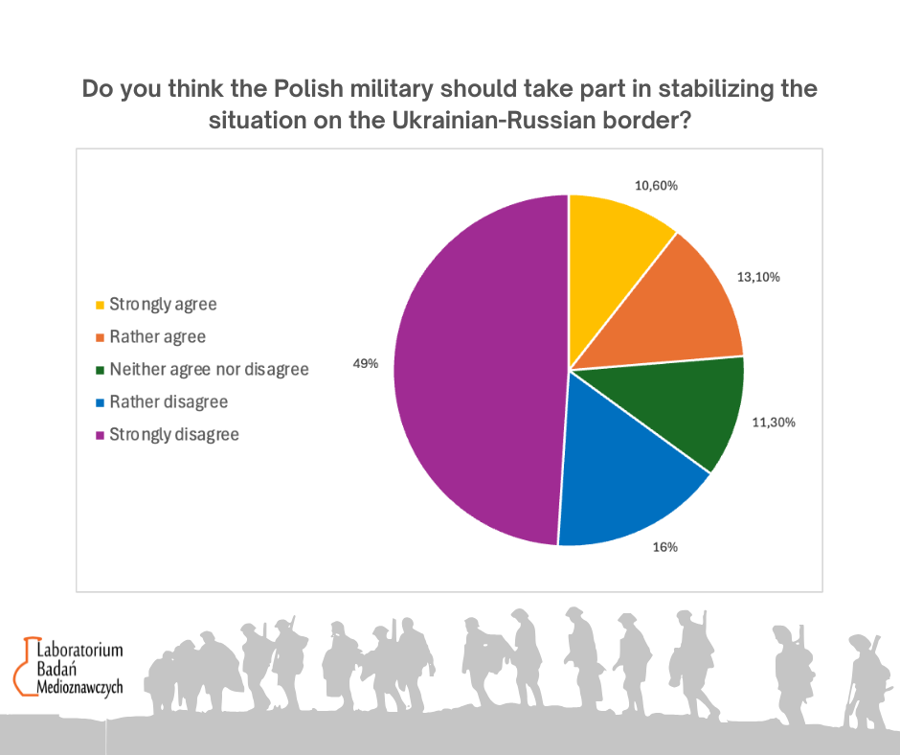

The majority of Polish women and men do not support the involvement of the Polish military in stabilizing the situation on the Ukrainian-Russian border. As many as 49% of respondents strongly oppose it, and another 16% rather disagree with such action. This means that a total of 65% of respondents express a negative stance toward potential military engagement by Poland in this region. On the other hand, 13.1% of those surveyed somewhat support the initiative, and 10.6% strongly support it, making nearly 24% in total who are in favor of such a solution. A neutral position—neither for nor against—is expressed by only one in ten people (11.3%).
These results clearly indicate that among those surveyed, reluctance toward Poland’s participation in the Ukrainian-Russian conflict dominates. At the same time, this is an issue on which people generally have a well-formed opinion.

Question 2: In your opinion, do most Poles agree with your view on this matter?
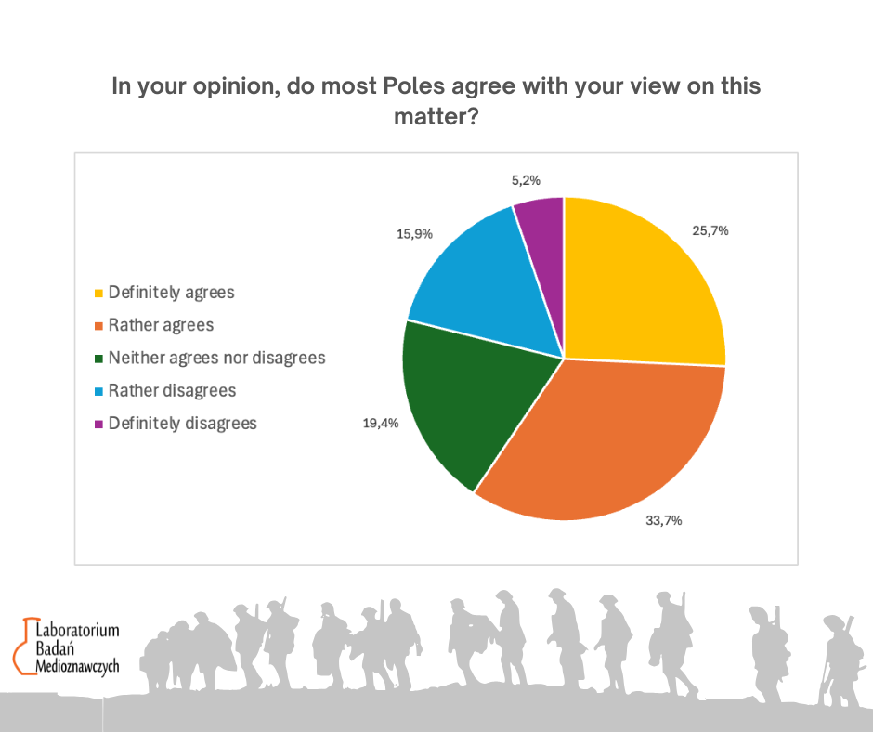

The results shown in Chart 2 illustrate how respondents assess the alignment of their opinion with the views of the majority of Poles regarding the military’s involvement in stabilizing the situation on the Ukrainian-Russian border. The largest group—33.7%—believes that most Poles rather agree with their position, while another 25.7% strongly believe in such alignment. Thus, the majority of Poles are convinced that their opinion corresponds with the views of the broader society. On the other hand, 19.4% are undecided, and 15.9% rather disagree, meaning they think their view is not dominant. Only 5.2% strongly believe that their opinion is isolated.

Question 3: In your opinion, will most Poles agree with your view on this matter in the future?
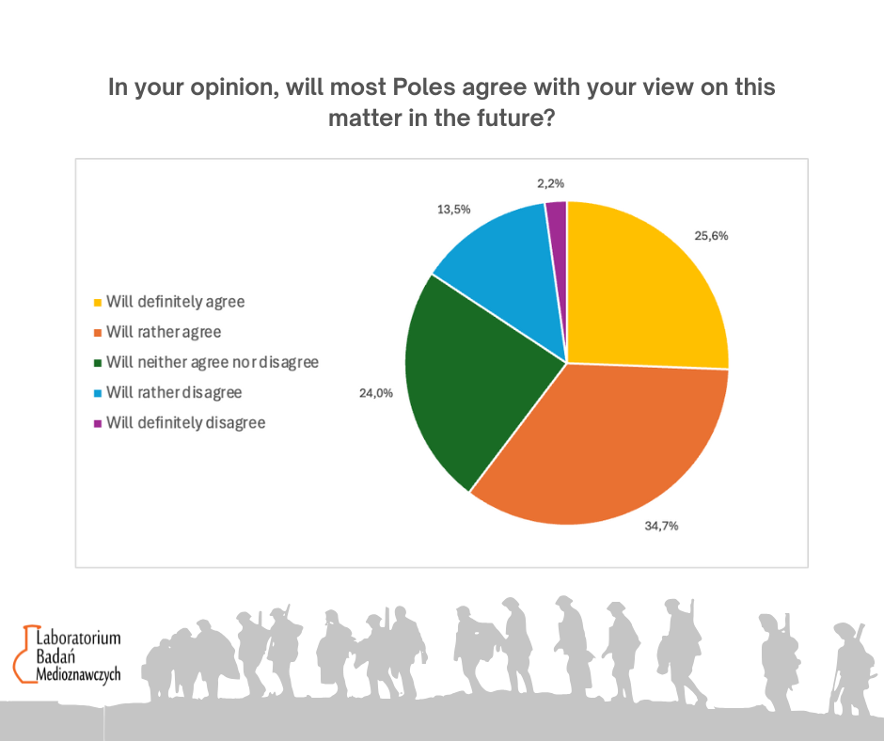

The next chart shows how respondents assess the likelihood that their opinion will be accepted by the majority of Poles in the future. The largest group—34.7%—believes that most of society will rather agree with their view, while 25.6% are firmly convinced of this. This means that a total of 60.3% of respondents anticipate that their position will gain broader support in the future.
Meanwhile, 24% remain neutral, neither expecting agreement nor opposition from the majority. Thirteen and a half percent (13.5%) think that most people will rather not share their opinion, and only 2.2% strongly reject this possibility. These results indicate significant optimism among respondents regarding the future acceptance of their views by the rest of society.

Question 4: Would you be willing to express your opinion about the involvement of the Polish military in stabilizing the Ukrainian-Russian border during a conversation with other passengers on a train?
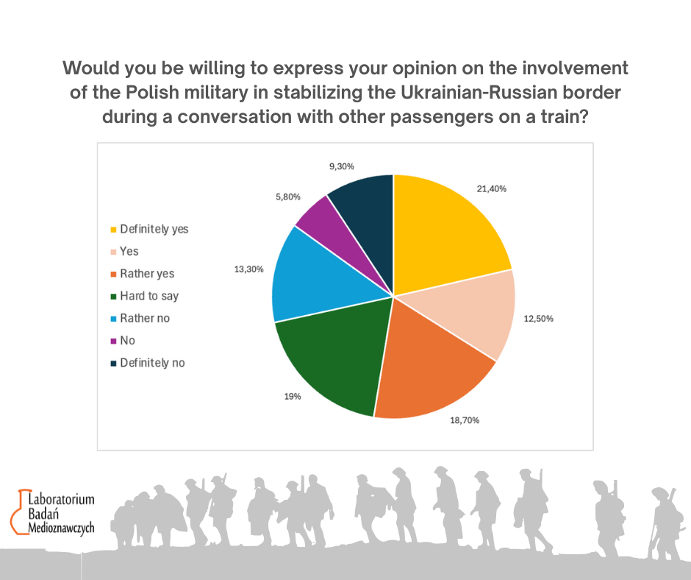

The results shown in Chart 4 present respondents’ willingness to share their opinion on the Polish military’s involvement in stabilizing the Ukrainian-Russian border in a situation where they are talking with random fellow passengers on a train. This question references the classic projection question from Elisabeth Noelle-Neumann’s original study, measuring disparities in willingness to share opinions among different groups.
The question aims to verify respondents’ readiness to discuss a fairly controversial topic in a public setting. In total, 52.6% of respondents declared such willingness: 21.4% definitely yes, 12.5% yes, and 18.7% rather yes. Meanwhile, 15.1% explicitly expressed reluctance to engage in such a conversation (5.8% “no,” 9.3% “definitely no”), and 13.3% would rather not speak up. Nearly one in five people (19%) found it difficult to clearly assess their stance.
These data indicate that only slightly more than half of society is willing to publicly express their views on this controversial topic, which may reflect a moderate level of confidence in their convictions or a moderate willingness to be publicly judged. Importantly, both groups (strong supporters and opponents of sending troops) do not differ significantly in their willingness to share their opinions, suggesting that the level of controversy associated with this issue is similar across respondent groups.

Question 5: Please rate on a scale how willing you are to discuss controversial topics in public?
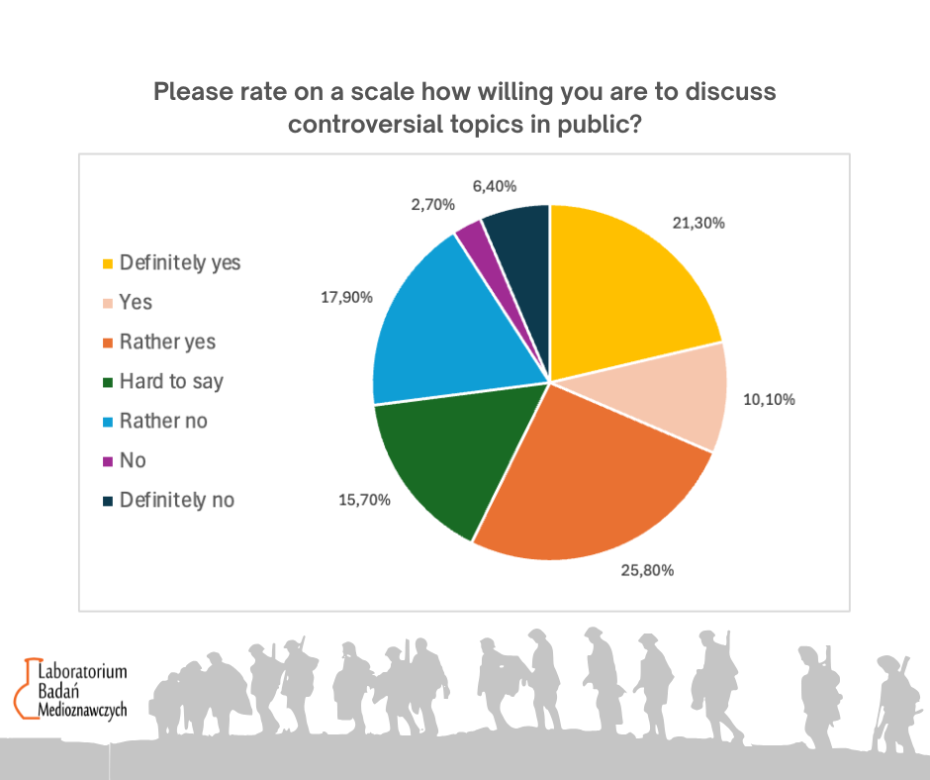

Chart 5 shows respondents’ willingness to publicly discuss controversial topics in general. The largest group—25.8%—is somewhat willing to engage in such conversations, while another 21.3% definitely express this willingness. This means that nearly half of those surveyed (47.1%) are open to public debate on contentious issues.
On the other hand, 17.9% of respondents tend to avoid such discussions, 2.7% definitely avoid them, and 6.4% do not want to participate at all—altogether making up 27%. Additionally, 15.7% are unable to clearly define their stance.
The results indicate that despite the presence of a group avoiding controversial topics, nearly half of respondents declare a readiness to openly express their opinions, even on difficult and divisive matters.

Question 6: Will you participate in the upcoming election this Sunday?
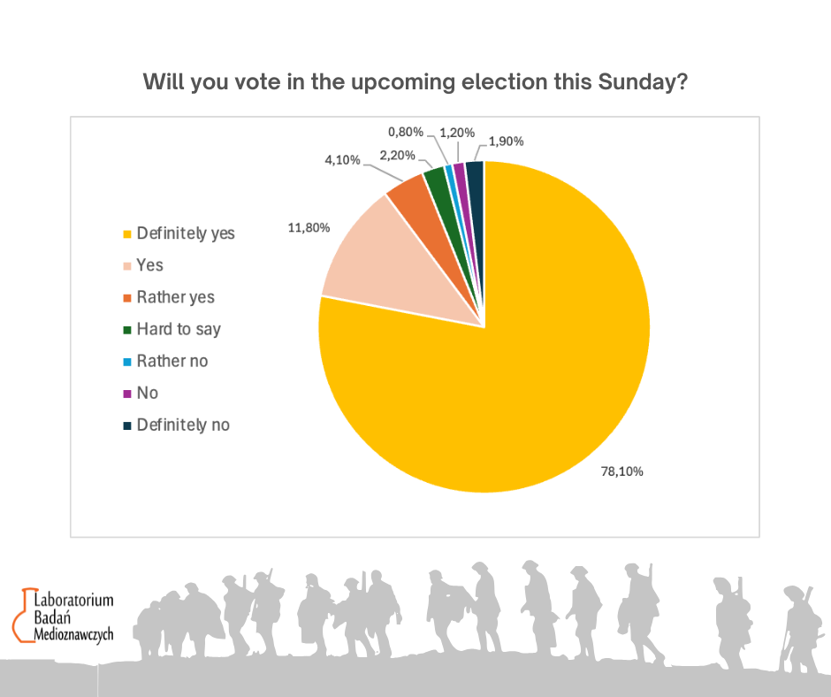

Finally, nearly all respondents expressed a willingness to take part in the presidential election scheduled just a few days after the survey. As many as 94% of those surveyed announced their intention to vote (78% definitely yes, almost 12% yes, and 4% rather yes). Only 4% did not plan to cast their ballot, and just over 2% were undecided about whether they would participate in the election.

Expert commentary from LBM UW
dr hab. prof. Tomasz Gackowski, University of Warsaw
The results of our study are thought-provoking. Nearly three-quarters of respondents distance themselves from active participation in public debate, especially when the topic might "break through" beyond the dominant media narratives. This phenomenon perfectly illustrates how strongly the “spiral of silence” mechanism operates in Polish society — a concept that assumes people avoid expressing unpopular (or perceived as such, particularly in mainstream media) opinions for fear of social exclusion.
Importantly, this mechanism does not only activate in response to “minority” opinions — it also operates when someone believes that dominant media, elites, or experts present views that differ from the “majority of ordinary people.”
This phenomenon resembles a notable moment of reflection in the American media after Donald Trump’s election, when CNN and other mainstream players had to admit they fundamentally misunderstood American society, which they had been observing only through the filter of their own editorial biases. A similar mechanism may be at work in Poland today — on one hand, we have dominant media and expert narratives, and on the other, a growing number of people who feel their views are not reflected in these narratives.
Furthermore, the topic of Poland’s military involvement acts as a particularly strong “trigger,” provoking withdrawal and self-censorship. But this may also signal a deeper process: the decline of trust in large, uniform mainstream narratives and the gradual retreat of people from open dialogue. If so, we are witnessing a worrying symptom: not so much a lack of opinions, but a lack of spaces where opinions can be safely and freely expressed.
In this context, for example, the electoral result of Grzegorz Braun (6.34%, 1,242,917 votes) in the first round of the presidential election was a complete surprise to the media, pollsters, and social-political commentators. Braun’s media exposure was marginal (except for popular debates), yet he managed to achieve a better result than all coalition government leaders except Rafał Trzaskowski.
If one tried to predict the results of the 2025 presidential election (first round) based on media exposure of individual candidates, the mainstream media would have made one of the largest cumulative errors in the history of the Third Republic of Poland (correlation between media exposure in mass-reach media (television) and election results).
It is clear that the influence of mainstream media on voters is significantly decreasing, and “media ostracism” no longer works as it used to years ago. Candidates can reach their voters alongside and beyond mainstream media.

dr Karolina Brylska
Although the vast majority of respondents have a clearly defined position on the issue we studied (the involvement of Polish troops in stabilizing the Russian-Ukrainian border), only half would be willing to express it publicly, for example, in a conversation with strangers. This demonstrates a significant gap between holding an opinion and the willingness to reveal it — a classic mechanism of the spiral of silence.
Even though as many as 60% of respondents believe that their stance on sending Polish troops to Ukraine is shared by the majority of society — both now and in the future — only 47% declare readiness to discuss controversial topics. Additionally, one in four respondents (27%) explicitly avoids such conversations. This discrepancy between “I know what I think” and “I can say it” likely reflects a potential fear of judgment.
In a society as politically polarized as ours, talking about controversial topics in direct contact with others probably seems too risky, too exhausting, or, worse, pointless. This is a conclusion that may carry significant negative consequences for the health of civil society in Poland and the quality of public debate.
The extremely high declared voter turnout (as much as 74% saying “definitely yes”) is likely due to the sample characteristics in our study (a relatively high representation of men, people from large cities, and the educated), which is interesting in itself. Interviewers reported that during attempts to start interviews, women would decline, arguing that they did not know enough about the study topic (“opinions about the military”) — even though interviewers emphasized that it was about expressing opinions, not precise knowledge.
Besides this, the unnaturally high declared turnout may result from a classic response bias, where respondents do not answer truthfully but rather express what they believe is the socially desirable opinion in this case.
---------
For more information, please contact:
dr hab. prof. UW Tomasz Gackowski (LBM UW)
t.gackowski@uw.edu.pl

dr Karolina Brylska (LBM UW)
karolina.brylska@uw.edu.pl

